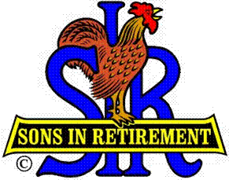

Las Trampas Branch 116

Executive Committee Meeting Agenda

April 16, 2018
9:30 AM
- Call Meeting to Order and confirm we have a quorum.
- Review Agenda/Minutes for Changes/Additions.
- Standing Reports:
Secretary – Fred Schafer: – Approval of March 19, 2018 minutes
Open Discussion
Attendance – Kevin Donahue:
Head count
Missed Luncheons
Open Discussion
Membership – Phil Goff:
New Members to be inducted: Jerry Zampino, Sponsor Bernie Wroblewski
Guests Today
Visitors
Open Discussion

Budget – Jim Nickels:
Open Discussion

- Big Sir Report:
- Growth in our Branch, State Big Sir Meeting
- Open Seating, Do we let it be or do we fix it.?
- Presidents Awards
- No meeting in May, Jerry Christopherson “Spring Fling”

- Little Sir Report:
- April Speaker:
- Committee Report
- Sate Website Report
- Other, Open Discussion

- Other Reports & Discussion

- Adjourn – 10:15 am

